 | 12.1.9 Editors - Geometry Nodes Editor - Header - Add Menu - Input - Scene
Table of content
Detailed table of content 1
Add menu - Input - Scene 3
Cursor 3
Active Camera 3
Camera Data 4
Collection Info 5
Image Info 5
Is Viewport 7
Named Layer Selection 7
Mouse Position 7
Object Info 8
Scene time 8
Self Object 9
Viewport Transform 9

Detailed table of content
Detailed table of content
Detailed table of content 1
Add menu - Input - Scene 3
Cursor 3
Outputs 3
Location 3
Rotation 3
Active Camera 3
Outputs 4
Active Camera 4
Camera Data 4
Inputs 4
Camera 4
Outputs 4
Projection Matrix 4
Focal Length 4
Sensor 4
Shift 4
Clip Start 4
Clip End 4
Focus Distance 5
Is Orthographic 5
Orthographic Scale 5
Collection Info 5
Inputs 5
Collection 5
Properties 5
Transform Space 5
Original 5
Relative 5
Outputs 5
Geometry 5
Image Info 5
Input 6
Image 6
New 6
Open 6
Image prop 6
Image browser 6
Image name 6
Fake user 6
New 6
Open Image 6
Remove 6
Frame 6
Outputs 6
Width 6
Height 7
Has Alpha 7
Frame Count 7
FPS 7
Is Viewport 7
Outputs 7
Is Viewport 7
Named Layer Selection 7
Inputs 7
Name 7
Outputs 7
Selection 7
Mouse Position 7
Outputs 8
Mouse X 8
Mouse Y 8
Region Width 8
Region Height 8
Object Info 8
Inputs 8
Object 8
Outputs 8
Transform 8
Location 8
Rotation 8
Scale 8
Geometry 8
Scene time 9
Outputs 9
Seconds 9
Frame 9
Self Object 9
Viewport Transform 9
Outputs 9
Projection 9
View 9
Is Orthographic 9

Add menu - Input - Scene
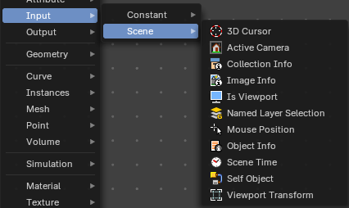
Here you find input nodes.

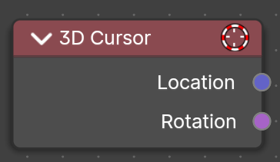
Cursor
The Cursor Geometry node gets the 3D Cursor location and rotation, for tool execution. Useful for creating tools with the 3D Cursor input from user.
Note that this node just shows with geometry nodes type Tool.

Outputs

Location
The location of the scene’s 3D cursor, in the local space of the modified object.

Rotation
The rotation of the scene’s 3D cursor, in the local space of the modified object.

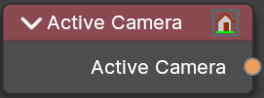
Active Camera
The node outputs the the scene's current active camera.
Typical usage would be to connect this node to an Object Info node to
obtain its transform.

Outputs

Active Camera
The active camera.

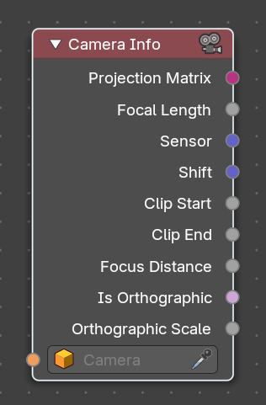
Camera Data
The Camera Info node provides various parameters from the active camera in the scene, allowing users to access and manipulate camera-related data within Geometry Nodes. This is useful for camera-driven effects, procedural framing, and depth-based modifications.

Inputs

Camera
An object value input. Specifies the camera object to retrieve information from.

Outputs

Projection Matrix
A 4x4 matrix output representing the camera’s projection transform. Combines focal length, sensor size, shift, and clipping range.
Useful for projecting 3D coordinates into screen space.

Focal Length
The focal length of the camera in millimeters. Affects the field of view in perspective cameras.

Sensor
The physical size of the camera sensor in millimeters. Outputs a 2D vector (X and Y dimensions).

Shift
Horizontal and vertical shift of the camera view. Outputs a 2D vector (X and Y dimensions).

Clip Start
The near clipping distance of the camera. Outputs a float value.

Clip End
The far clipping distance of the camera. Outputs a float value.

Focus Distance
The distance from the camera to the focus point, in Blender units. Typically used for depth of field calculations. Outputs a float value.

Is Orthographic
A boolean output that is true when the camera is in orthographic mode, and false when in perspective mode.

Orthographic Scale
The scale factor used when the camera is set to orthographic mode. Controls the size of the view area instead of using focal length. Outputs a float value.

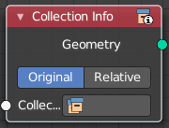
Collection Info
The Collection Info node retreives information from collections. This can be useful to use an external collection to control parameters in the geometry node tree.

Inputs

Collection
Collection to get the properties from.

Properties

Transform Space
The transformation of the geometry outputs.

Original
Output the geometry relative to the collection offset.

Relative
Bring the input collection geometry into the modified object, maintaining the relative position between the objects in the scene.

Outputs

Geometry
Geometry of the collection in world space with all its modifiers applied.

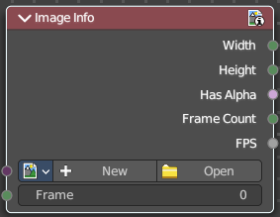
Image Info
Retreive infos from an image.

Input

Image
Load or connect a image.

New
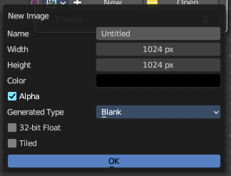
Create a new image.
Opens a new image dialog where you can adjust the color, size and further settings.

Open
Open a existing image.

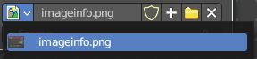
Image prop

Image browser
A list of available images

Image name
The name of the image

Fake user
Add a fake user to this asset.

New
Create a new image.
Opens a new image dialog where you can adjust the color, size and further settings.

Open Image
Open a existing image.

Remove
Removes the image as the active image.

Frame
For videos. Which frame to use.

Outputs

Width
The width of the image.

Height
The height of the image

Has Alpha
Returns true if the image has an alpha channel

Frame Count
For movies. How many frames.

FPS
For movies, what FPS rate.

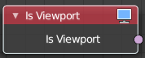
Is Viewport
The Is Viewport node outputs true when geometry nodes is evaluated for the viewport. For the final render the node outputs false.

Outputs

Is Viewport
A booleran that indicates if the geometry nodes is evaluated for preview.

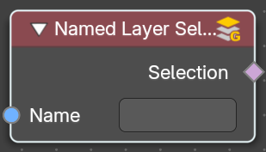
Named Layer Selection
Output a selection of a grease pencil layer by attribute name

Inputs

Name
The layer name attribute.

Outputs

Selection
The selected layer.

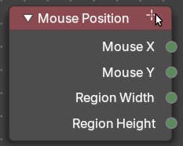
Mouse Position
Just in Tool mode !
Retreives the mouse position.

Outputs

Mouse X
Mouse X position.

Mouse Y
Mouse Y position.

Region Width
The total X size of the region in pixels.

Region Height
The total Y size of the region in pixels.

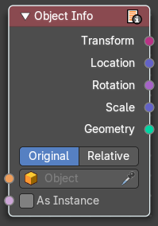
Object Info
The Object Info node retreives information from objects. And outputs it then.

Inputs

Object
Object to get the properties from.

Outputs

Transform
Transform matrix output.

Location
Location of the object in world space.

Rotation
Rotation of the object in world space.

Scale
Scale of the object in world space.

Geometry
Geometry of the object in world space with all its modifiers applied.

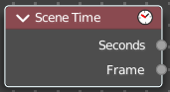
Scene time
Outputs the current scene time in seconds or in frames.
The Frame output is a float value to make subframe rendering for motion
blur possible.

Outputs

Seconds
Output in seconds.

Frame
Output in Frames.

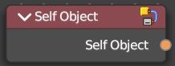
Self Object
Retreives the parent object of the geometry nodegroup.

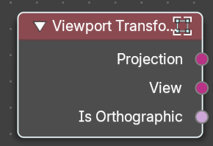
Viewport Transform
Just in Tool mode !
Gets and retreives the view direction and location from the 3D Viewport.

Outputs

Projection
Outputs the 3D Viewport’s perspective or orthographic projection matrix as a matrix transform value.

View
Outputs the view direction and location of the 3D Viewport as a matrix transform value.

Is Orthographic
Outputs a boolean to show if the camera is orthographic with a true or false value.

